JAVA ASSIGNMENT : 1

Write a program to check the entered user name is valid or not. Get both the inputs from the user.
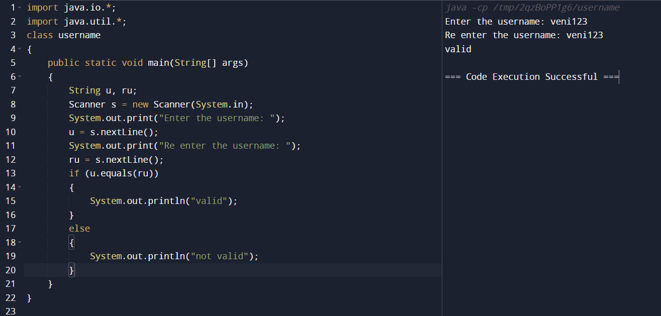

Write a program to find whether the person is eligible for vote or not. And if that particular person is not eligible, then print how many years are left to be eligible.

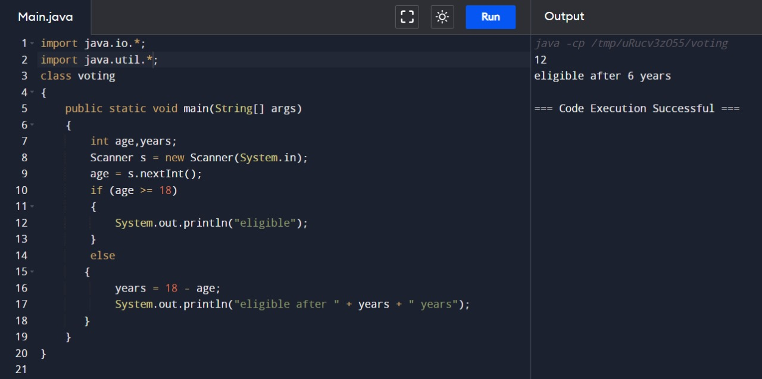

Write a program using function to calculate the simple interest. Suppose the customer is a senior citizen. He is being offered 12 percent rate of interest; for all other customers, the ROI is 10 percent.
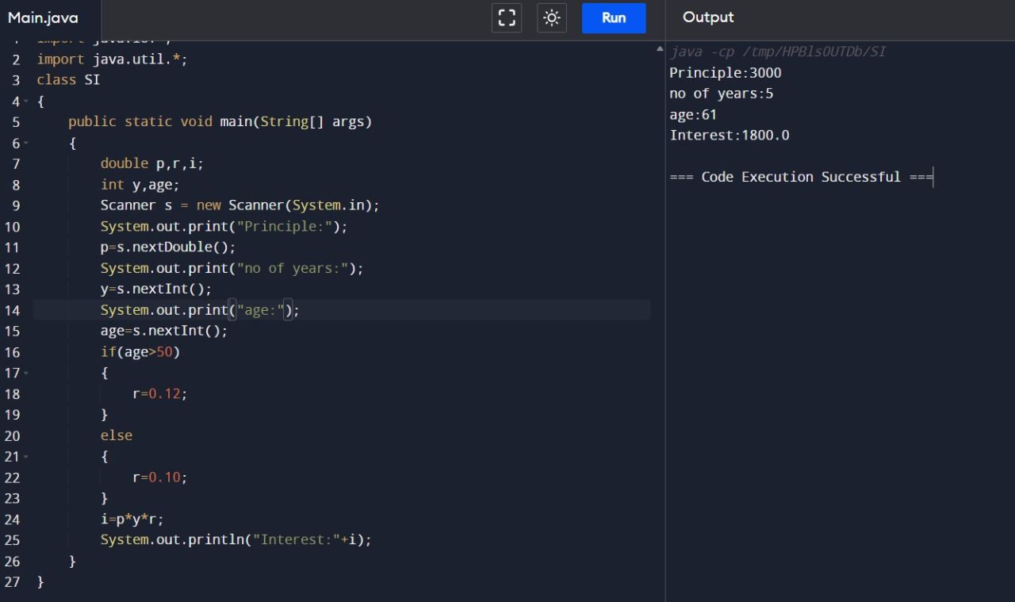

Program to find the year of the given date is leap year or not
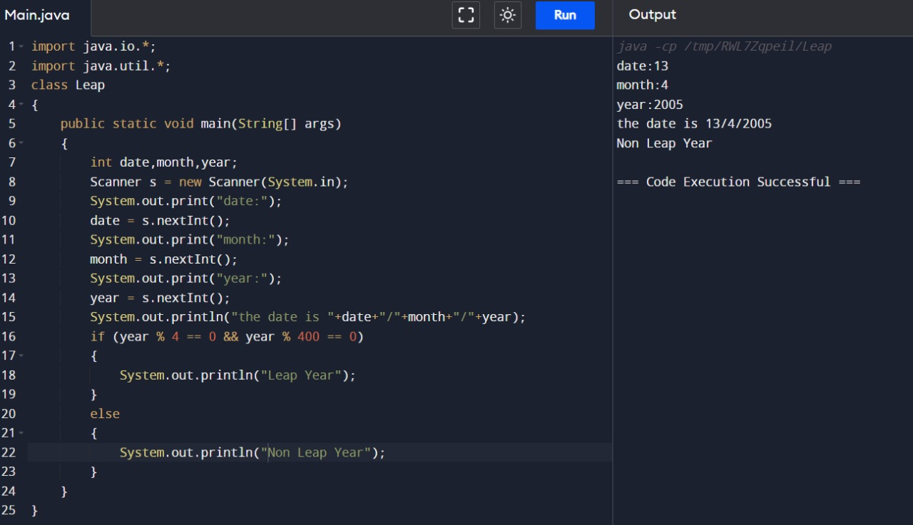

Write a program to find the square, cube of the given decimal number

